**Dahi-** Dahi or Curd is a dairy product obtained by souring boiled or pasteurized milk naturally, by harmless lactic acid bacteria or other bacterial cultures. Curd may contain a wide variety of bacteria like ***Lactobacillus bulgaricus and Streptococcus thermophelus***. Curd is reported to have better nutritive value than milk. Though there is no increase in the fat or protein content of milk during fermentation, the digestibility of curd is more than that of milk. The calcium and phosphorous contents of curd are more easily assimilated. Curd contains more vitamins than milk. During curd formation the lactose of milk is converted into lactic acid. There is some breakdown of protein increasing the non-protein nitrogen. The fat globules coalesce and distribute themselves on the top. Physically during curd formation milk proteins are jellied and thin exudates of clear serum on the curd is seen. The acidity of Dahi is 1% lactic acid.

Equipments- Plate heat exchanger or Vat, Homogenizer (optional), Cup filling and sealing machine, Pump, Multipurpose head, Plastic container for packaging.

FLOW CHART

RAW MILK (3-4% fat, 7-8% SNF)

↓

Standardization/Reconstitution of the milk to raise SNF to 10-11%

↓

Pasteurization ( 85-95⁰C for 10-15 mins)

↓

Homogenization at 60⁰C,1500 psi& Cooling to 37-40⁰C

↓

Addition of Dahi/Yoghurt Culture @ 1%→(**Dahi**=*Lact. Lactis,*

*Lact.Diacetylactis & Lact.Cremoris*

**Yoghurt** =*Str. Thermophilus*

*& Lact. Bulgaricus*)

↓

Addition of Sugar@ 3%(optional)

↓

Filling in cups of size 100-500g(Manual/Filling Machine)

↓

Incubation at 37-42⁰C for 4-5 hrs(Dahi Incubator)

↓

Dahi/Yoghurt sets in cups

↓

Dahi/Yoghurt cups in trays/crates are removed from incubation room and stored at 4 ⁰C

**Paneer** -To prepare paneer, food acid (usually lemon juice, vinegar, citric acid) is added to hot milk to separate the coagulated matter from the whey. The coagulated matter is drained in muslin cloth and the excess water is pressed out. The resulting paneer is dipped in chilled water for 2–3 hours to give it a good texture and appearance.

Equipments- Plate heat exchanger or Vat, Paneer Vat for coagulation, Chill water Tank, Paneer press, Paneer putting machine with table, Vacuum packaging machine.

FLOW CHART

MILK (3-4% fat, 7-8% SNF)

↓

Heat in Vat to 85- 90 C for 5-10 mins

↓

Add 1% citric acid, stir slowly. Coagulum settles down in 10 mins. Whey is strained

↓

Coagulum is removed from Vat. Filled in muslin cloth and placed under pressure 5 times the weight of paneer for 15-20 mins.

↓

Paneer blocks are removed and placed in chilled brine (4%salt) water at 4 C for 2 hours

↓

Paneer blocks are cut in pieces and stored

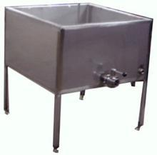 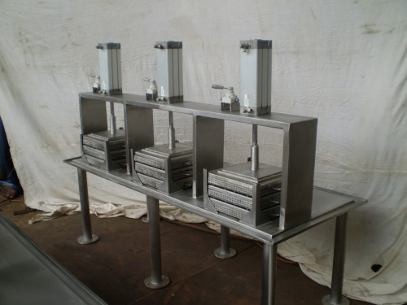

**Cream**- Cream is the fat rich part of milk obtained from Cow’s or Buffalo’s milk or a combination thre of and containing not less than 25% fat.

Classification-

* Table cream / light cream (25% fat)
* Whipping cream / heavy cream (20-40% fat)
* Plastic cream (65-85% fat)

Principle of Cream Separation- The basic principle of cream separation whether by gravity or the centrifugal method is based on the fact that milk fat is lighter (sp.gravity 0.93) than the skimmed milk portion (sp.gravity 1.036). The two components gets separated when subjected to centrifugal force or gravity separation. The gravity method is a slow process resulting in souring of cream and skimmed milk. It is no longer used for commercial production of cream.

In the centrifugal method, cream is separated essentially on the principle of Stock’s law. Stock’s equation states

Where, V = velocity of movement of fat globule.

r = radius of fat globule.

ds = density of skimmed milk.

df = density of milk fat.

N = speed of bowl (revolution/min)

R = distance of fat globule from the axis of rotation.

K = constant

ɳ= viscosity of skimmed milk

According to his equation the rate of cream separation increases with increase size of fat globule, greater difference in density between fat and skimmed milk, higher speed of bowl (rpm), bigger size of bowl, lower viscosity of skimmed milk.



*Fig- Cream Separator*